**Custom Made High Gloss Chinoiserie Brass Ming Hardware Wall Mirror**

**Price: $450**

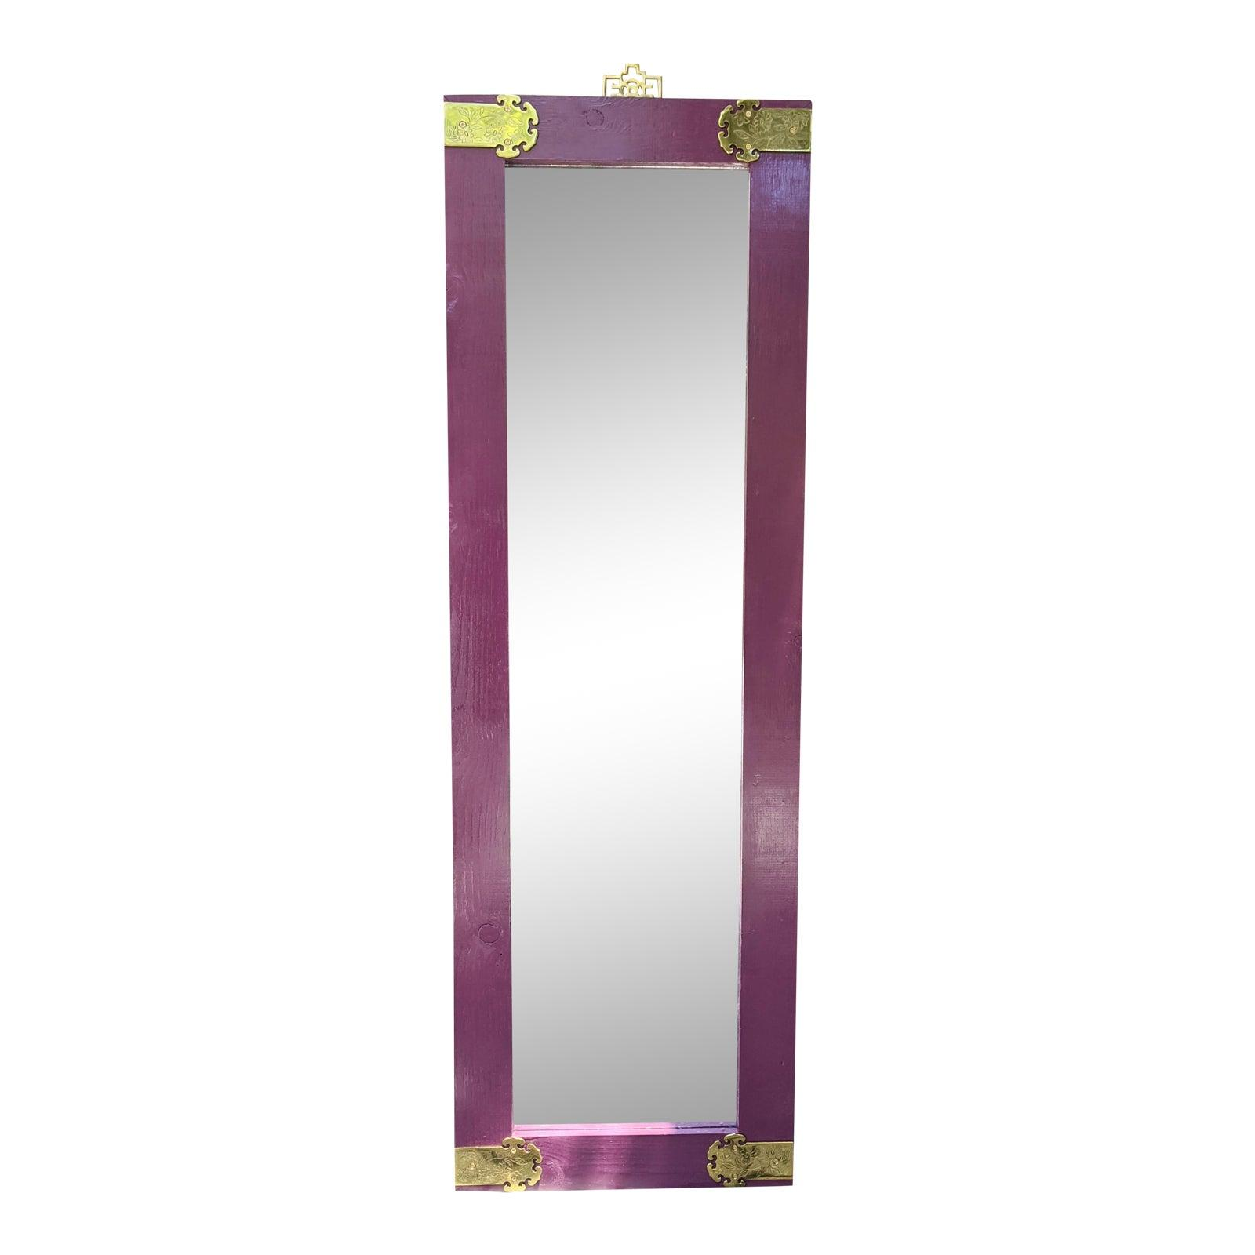

* CATEGORIES

Drawing/Living room mirrors

* MATERIALS

Wooden framed

* SHAPE

Rectangle

* BRAND

Viglacera